
Program: CSE STAR C | Semester: IV
Course Name: WEB TECHNOLOGIES | Course Code: 23CSE404
Submission Date: 12/04/2026 | Year: II
Name: Vishrutha G | USN: 24BTRCT147
LAB EXERCISE 9

﻿﻿9. Create, store, retrieve and display the product details for Exercise 2 using PHP and MySQL.
Step 1: Create Database & Table (MySQL)

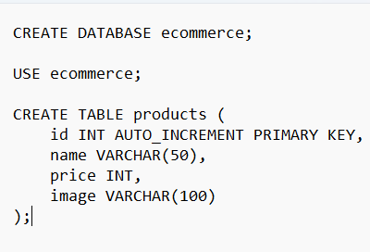

Step 2: Database Connection (db.php)

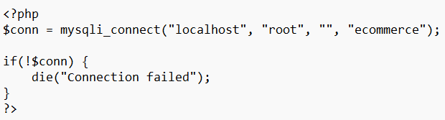
Step 3: Insert Product (insert.php)

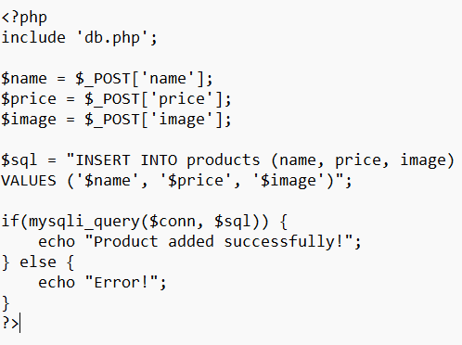

Step 4: Product Form (add_product.html)

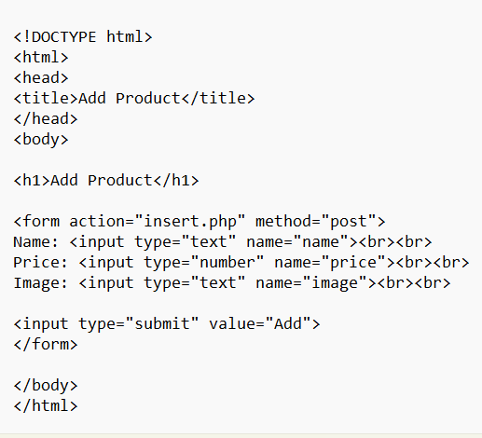
Step 5: Display Products (display.php)

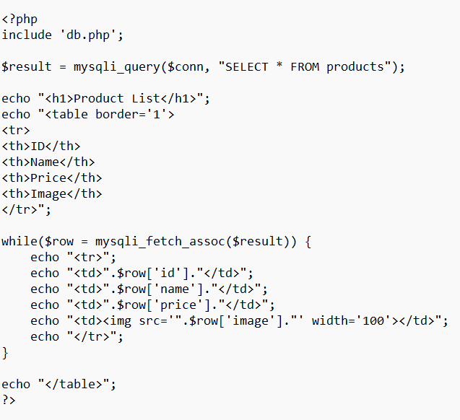

OUTPUT:

